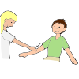  Touching others during carpet time | 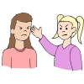  Hitting | 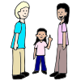  Saying “excuse me” when I want someone to move
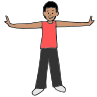  Keeping my body to myself | 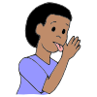  Licking people | 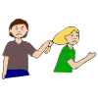  Grabbing
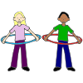  Staying out of other people’s comfort bubble | 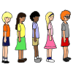  Keeping my hands to myself in line | 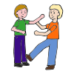  Kicking others
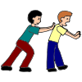  Pushing | 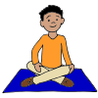  Sitting where I’m not tempted to touch others | 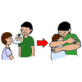  Asking before giving a friend a hug

Name: __________________________________ Date: _____________
Personal Space Camp by Julia Cook
What is personal space?
/////////////////////////////
Personal space is the amount of space you need to feel comfortable. Cut out the pictures of choices you can make at school. Sort the pictures into the good choices column and the bad choices column.
Good Choice | Bad Choice

How do you feel when someone invades your personal space?
//////////////////////////////////////////////////////////
Draw a picture of a good choice you will make to respect someone else’s personal space:

/////////////////////////////
/////////////////////////////

